Introduction
The EPIC ClearView is a non-invasive digital bio-electrography instrument that is used to assess the electrophysiology of humans. The measurements are digital photographs, i.e. images taken in a brief exposure to an electric field of each fingertip. The EPIC ClearView device measures the instantaneous current flow from the skin through a small high frequency electric charge applied to the skin surface. The electric circuit consists of: (1) an electrode with a glass dielectric (insulator) that contacts the subject’s skin, (2) the EPIC ClearView device, (3) the subject’s body capacitance to earth representing the charge/return connection. When the high frequency charge is applied through the glass dielectric to the skin, this instantaneous current flow reflects the resistance of the skin on the fingertip presented as varying light intensities.

A subject will have images taken of each of their 10 fingertips twice, once through without a capacitive barrier (autonomic system) and once through with the capacitive barrier (physical system), for a total of 20 images.

The calibration process has been proposed as a method of assessing device performance prior to collection of subject data. The calibration process utilizes a calibration probe (part 06680) and a calibration cable to create an artificial energized image which will be analyzed to determine appropriate performance characteristics. This calibration pass/fail requirement must be determined to meet the requirements or users will be prevented from capturing subject data.

The current version of ClearView is 0.9.7.8.

Calibration Testing Plan
The new process for the ClearView calibration was tested in two parts.

2.1 Part 1 of Testing
Initially, the Medical Scientist was provided at least 50 sets of historical calibration images across three different machines (SN007, SN009, and SN025). These historical calibration images were qualitatively assessed by the Medical Scientist as either pass (P) or fail (F). The explanation of how the qualitative assessment completed is explained in detail in the Results section below.

The assessments of these images were to be analyzed to determine if any of the environmental factors have an effect on the pass or fail assessment. The environmental factors included the following:

- Machine Number of Calibration Image (SN007, SN009, or SN025)
- Temperature (°F)
- Humidity (%)
- Pressure (Hg)
- Adequate Warm Up (AWU) of >20 minutes (Y/N)

Date of calibration, serial number of machine, temperature, humidity, pressure, and the time device was turned on, the time the device was calibrated, and the pass/fail classification were to be data entered into a validated excel spreadsheet for recording environmental factors. Time between calibration time and device on time was to be derived by calculating the difference, in hours, between the time the machine was calibrated and the time the machine was turned on. The Adequate Warm Up time was to be derived by classifying time between calibration time and device on time as a 1 when this value is ≥20 minutes and a 0 when <20 minutes.

The analysis for assessing the above factors on the qualitative assessment of the historical calibration images was conducted using a logistic regression model. This model included the pass/fail classification as the response variable, the machine number and adequate warm up time as categorical explanatory variables, and temperature, humidity and pressure as continuous explanatory variables. This analysis was to determine if any of the environmental factors will need to be accounted in the new calibration process.

The analysis above was to be completed using SASv9.8.2 proc logistic.

2.2 Part 2 of Testing
The second part of the process was to collect new calibration images adjusting for the results based upon Part 1, if necessary. The new calibration images will be used to determine non-parametric tolerance limits (Conover, 1980) around the intensity of each pixel in a calibration image. The level of the tolerance to be used will be 95% certain that 90% of the intensity values at each pixel were to be between the calculated interval from the new images.

The sample size needed to determine the tolerance limits follows from the referenced method, which uses the following formula:

n=0.25*(χ_{1-α})*[(1+q)/(1-q)] + 0.5

where χ_{1-α} represents the 1-α quantile of the chi-squared distribution, and
q represents the percentage of future intensity levels that will fall within the calculated intervals

Based on the above assumptions the sample size required was 46 images across the 3 machines. Once these images are collected, the minimum and maximum values for each pixel of all of the images collected will become the calibration tolerance limits was to be used in the new calibration process.

If the analysis in Part 1 shows that the results need to be adjusted for each machine, then the sample size above will be applied to each machine, i.e. 46 new calibration images collected from each machine. Tolerance limits will then be calculated for each machine.

The above analysis was to be completed using MATLABv7.8.0.

2.3 Verification of Testing
The ClearView software solution will be updated based on this test plan and appropriate software verification and validation will be performed. Subsequently, the images collected in Part 1 above was to be used to verify the calculated limits determined in Part 2. Each of the historical images will be compared to the tolerance limits using the ClearView software. The percentage of correct classification will be calculated, along with the associated 95% confidence interval based on the normal approximation. This verification is to be used to determine if an error rate acceptance should be employed.

If the results of this verification show that these limits are not adequate, then a new testing plan will be written and executed.

Data and Image Collection

3.1 Initial Image Collection
The images collected for the initial testing are stored on the images network within the following path:

I:\Calibration_Testing\APR2011\Image_Files

The images were all renamed with consistent and informative file names in the structure of:

#a_SNbb_yyyymmdd_hhmm, where #a represents the finger number & hand, SNbb represents the serial number of the machine the image was taken from, yyyymmdd represents the year/month/day the image was captured, and hhmm represents the time in hours and minutes (military time, i.e. 24 hr clock) the image was captured.

The data for the environmental factors described in Part 1 were data entered from the calibration logs. The file is stored in the following path:

I:\Calibration_Testing\APR2011\Image_Files

3.2 New Calibration Images
The new calibration images collected were collected for each of the 3 machines. There were 60 total images taken from each machine and theses images are stored on the images network within the following path:

I:\Calibration_Testing\APR2011\NewCal_Images

The images were all renamed with consistent and informative file names in the structure of:

SNbb_xx_#a, where SNbb represents the serial number of the machine the image was taken from, xx represents the image number taken, and #a represents the finger number & hand.

3.3 Adhoc Calibration Images
A significant difference in the predicted probability of a “Pass” between machines SN009 and SN025 was determined during the New Calibration Images analysis. Therefore, a set of adhoc calibration images were taken from machine numbers SN009 and SN025. The adhoc images files for SN025 were taken in the AM and PM on April 25, 2011 through April 29, 2011. The adhoc images for SN009 were taken in the PM on April 26, 2011 through April 29, 20011 and on May 2, 2011 and in the AM on April 26 and May 2. A total of 164 adhoc images were taken across the two machines. These images are stored on the images network within the following path:

I:\Calibration_Testing\APR2011\AdHocNewCal_Images

The images were all renamed with consistent and informative file names in the structure of:

SNbb_xxyM_#a, where SNbb represents the serial number of the machine the image was taken from, xx represents the image number taken and yM represents AM or PM, and #a represents the finger number & hand.

Results

Results for the planned analysis are based on calibration images from three ClearView machines: Serial Number (SN) 07, SN009 and SN025. Results using the adhoc calibration images are based on machines SN009 and SN025. This report describes the results from the analyses described in the sections below.

Each image was assessed first by confirming proper placement of the calibration probe. If the probe is offset from the glass a perturbation of the inner area will show a greater intensity than the typical ‘black’ background. Each image was then qualitatively assessed for symmetry of intensity throughout the image (from the inner radius towards the outer edge), inner radius regularity, and area regularity. Each set of 10 calibration images are assessed for reproducibility by assessing across images the inner radius regularity, area regularity and average intensity.

4.1 Planned Analysis Results: Assessment of Environmental Factors

    - Part 1
A total of 680 calibration images were taken across 68 sets from 3 machines, SN007, SN009 and SN025. Of these 68 sets, 35 sets were qualitatively assessed as passed, i.e. 350 calibration images considered pass, while 33 sets were qualitatively assessed as failures.

The environmental factors included those listed in Section 2.1 and additional factors listed below:

- Center coordinate values of the center of the image
- ‘x,y’ radius values of the image
- Set number
- Adequate warm up time >30 minutes (Y/N)

The environmental factors that were data entered, as described in Section 2.1, for each calibration set are provided in Appendix 1. The additional factors that were not calculated from those listed in Appendix 1 were imported from the calibration text files of the image data processed by ClearView. All data analysis of these environmental factors was conducted using SAS v9.2.1.

Descriptive statistics for all environmental factors are provided in full detail in Appendix 2. Overall humidity, temperature, and pressure had a mean of 37.3 percentage points, 74.6 degrees F, and 29.9 Hg, respectively. Across the three machines, the humidity was on average higher for SN007 than it was for SN009 and SN025 (43.7 vs 31.7/36.2 percentage points). Adequate warm up time was approximately the same across machines with the exception of SN009 AWU>30 minutes, where 50% of the calibration sets had at least 30 minutes of warm up time. This is mostly due to the fact that SN009 is currently used for scanning at the Greater Baltimore Medical Center (GBMC) clinical trial. More specifically, the GBMC SN009 machine is used regularly such that the time between the machine turn on and the time of the first patient scan for the day is much shorter than the time for machines SN007 and SN025.

Tables 1 displays the descriptive statistics for select environmental factors by machine, and overall. Additional factors excluded from Table 1, such as Centerpoint of Image and Radius of Image, etc., were not used in this evaluation. A complete set of the calibration data is located in Appendix 2.

Table 1. Descriptive Statistics for Select Environmental Factors by Machine Type

Environmental Factor | SN007  N=23 | SN009  N=22 | SN025  N=23 | Overall  N=68
Humidity | 43.7±13.65 | 31.7±10.51 | 36.2±10.54 | 37.3±12.53
Temperature | 73.8±1.35 | 75.1±1.84 | 74.8±4.3 | 74.6±2.82
Pressure | 29.9±0.15 | 29.9±0.35 | 29.9±0.11 | 29.9±0.23
AWU>20min | 22 (95.7) | 19 (86.4) | 23 (100) | 64 (94.1)
AWU>30min | 21 (91.3) | 11 (50.0) | 21 (91.3) | 53 (77.9)
Note: All descriptive statistics provided are mean±SD for continuous factors and n(%) for categorical factors.
Note:N=sets of calibration images; AWU=Adequate Warm Up Time.

Descriptive statistics are also provided in Table 2 for the same environmental factors, as listed above, by machine and pass/fail criteria.
Table 2. Descriptive Statistics for Select Environmental Factors by Machine Type and Pass/Fail Criteria

Environmental Factor | P/F | SN007  Np=8  Nf=15 | SN009  Np=16  Nf=6 | SN025  Np=11  Nf=12 | Overall  Np=35  Nf=33
Humidity | Pass | 48.3±10.53 | 31.4±9.93 | 35.5±8.47 | 36.5±11.52
 | Fail | 41.2±14.79 | 32.5±12.93 | 36.9±12.49 | 38.1±13.65
Temperature | Pass | 73.6±0.88 | 75.0±1.75 | 74.6±4.87 | 74.6±2.96
 | Fail | 73.95±1.56 | 75.33±2.23 | 74.85±3.87 | 74.5±2.70
Pressure | Pass | 29.9±0.11 | 29.8±0.39 | 29.9±0.09 | 29.9±0.27
 | Fail | 29.9±0.17 | 30.1±0.15 | 29.9±0.14 | 29.9±0.16
AWU>20min | Pass | 8 (100) | 14 (87.5) | 11 (100) | 33 (94.3)
 | Fail | 14 (93.3) | 5 (83.3) | 12 (100) | 31 (93.9)
AWU>30min | Pass | 8 (100) | 8 (50.0) | 10 (90.9) | 26 (74.3)
 | Fail | 13 (86.7) | 3 (50.0) | 11 (91.7) | 27 (81.8)
Note: All descriptive statistics provided are mean±SD for continuous factors and n(%) for categorical factors.
Note:N=sets of calibration images; AWU=Adequate Warm Up Time.

The determination of each environmental factor having a significant effect on the pass/fail qualitative assessment was conducted using logistic regression models, with each factor assessed individually. The logistic regression model is modeling the probability of a pass calibration set with each factor, individually, included in the model as an explanatory variable.

Table 3 displays the results of the individual models for all factors along with their associated p-values assessing significance. The one factor that is deemed of having a significant effect on a calibration set being assessed as ‘Pass’ is machine ID. The odds of SN025 having a passing calibration set is 1.8 times that of SN007 (p=0.047). Similarly, the odds of SN009 having a calibration set being assessed as ‘Pass’ is 2.9 times that of SN025 (p=0.018). No other factors were deemed to have a significant effect on a calibration set being deemed as ‘Pass’.

Table 3. Logistic Regression Results for Select Environmental Factors

Environmental Factor | Odds Ratio Estimate | 95% CI | P-Val
Humidity | 1.0 | (0.95, 1.03) | 0.609
Temperature | 1.0 | (0.85, 1.19) | 0.948
Pressure | 0.3 | (0.04, 3.08) | 0.333
AWU>20min | 1.1 | (0.14, 8.03) | 0.952
AWU>30min | 0.6 | (0.20, 2.06) | 0.456
Set # | 1.0 | (0.99, 1.04) | 0.420
Machine ID* | SN025 vs SN007: 1.8  SN009 vs SN025: 2.9 | (0.53, 5.61)  (0.84, 10.10) | 0.047  0.018
Note: The models for center and radius were not reported due to low frequency in cell counts. SAS output for these models are reported in Appendix 2.
Note:CI=Confidence Interval; AWU=Adequate Warm Up Time; P-Val=p-value for significance of model term(s).
*Note: SN025 was used as reference machine in this model.

Subsequent models were conducted for each of the other factors while adjusting for machine ID. None of these models provided additional significant covariates, hence the model including only machine ID is the only model to be discussed for Part 1 of these analyses results. From the model to only include machine ID, predicted probabilities of calibrations sets being assessed as ‘Pass’ can be calculated. Table 4 displays the predicted probability of a calibration set being assessed as ‘Pass’ by machine ID and overall.

Table 4. Predicted Probabilities for a Calibration Set Being Assessed as ‘Pass’

Machine ID | Predicted Probability of ‘Pass’ Calibration Set  (95% CI)
SN007 | 34.7% (18.4, 55.7)
SN009 | 72.7% (51.1, 87.2)
SN025 | 47.8% (28.8, 67.5)
All Machines | 51.5% (39.7, 63.1)
Note:CI=Confidence Interval.

In conclusion, there is a significant difference between machines in calibration sets being assessed as ‘Pass’. The next step in the investigation was to collect new images from each machine and determine if an acceptance range could be established to more accurately discern the difference between passed and failed images.

4.2 Planned Analysis Results: Assessment of New Calibration Images

Based on the planned analysis results from 4.1, new images were taken from each machine for assessment of pass/fail. These new images were collected with the intention of determining non-parametric tolerance limits (Conover, 1980) around the intensity of each pixel in a calibration image. This methodology provides 95% certainty that 90% of the intensity values are within these limits at each pixel. Sample size calculations for this methodology required 46 calibration images from each machine, see Section 2.2.

The new images were taken for SN007 and SN025 in-house with 60 immediate consecutive calibration images collected towards the end of the day on April 18, 2011. New images for SN009 were taken in immediate consecutive manner at the end of the day on April 21, 2011. All 180 new images were individually assessed as a ‘Pass’ or ‘Fail’ qualitative determination. The qualitative assessment of these new calibration images are listed in Appendix 3.

Based on these qualitative assessments, all images from SN007 failed. Due to this result, images captured from SN007 are removed from further analysis and it is recommended to have SN007 mechanically assessed to determine whether the unit verification settings match the release criteria. SN009 and SN025 are then used in a logistic regression model that uses the qualitative assessment as the response variable with machine ID as the covariate in the model. Table 5 summarizes the descriptive statistics of the new images for SN009 and SN025, while Table 6 displays the results from the logistic regression model. Descriptive statistics and the results from the logistic regression model are reported in full in Appendix 4.

Table 5. Descriptive Statistics of the Pass/Fail Assessment
Machine ID SN009 and SN025

Machine ID | Assessment | n (%)
SN009 | Pass | 50 (83.3)
 | Fail | 10 (16.7)
SN025 | Pass | 30 (50.0)
 | Fail | 30 (50.0)

Table 5. Logistic Regression Results and Predicted Probabilities for a Calibration Set Being Assessed as ‘Pass’
New Calibration Images

Machine ID | Odds Ratio Estimate  (95% CI) | P-val | Predicted Probability of ‘Pass’ Calibration Set  (95% CI)
SN009 | vs SN025  5.0 (2.1, 11.7) | 0.002 | 83.3% (71.7, 90.8)
SN025 |  |  | 50.0% (37.6, 62.4)
Both Machines |  |  | 66.7% (57.8, 74.5)
Note:CI=Confidence Interval; P-Val=p-value for significance of model term(s).
*Note: SN025 was used as reference machine in this model.

The percentage of passed sets for SN009 was 71.7% when compared with the percentage of individual passed images of 83.3%; similarly for SN025 the percentage of passed sets are 47.8% vs 50.0% for assessing individual images. Although the percentages of ‘Pass’ images are higher for the new calibration images for SN009 and SN025, the fact remains that all new calibration images for SN007 were assessed as ‘Fail’.

When SN009 and SN025 new images were taken, a significant difference existed in the predicted probability of a “Pass” between machines (Table 5). Hence, it was determined to collect the set of adhoc images to assess any variability throughout the day.

4.3 Adhoc Analysis Results: Assessment of Adhoc Calibration Images

Based on the results from Section 4.2, an assessment was conducted to determine if collecting calibration images consecutively towards the end of the day (as the samples from the New Calibration testing in section 4.2) shows different results than collecting a set of calibration images after the specified warm up time. It was decided to collect additional adhoc calibration images over the course of 5 days both at the beginning of the day and at the end of the day (as described in Section 3.3) from both SN025 and SN009. These images were individually assessed qualitatively by the medical scientist and are reported in Appendix 5.

There were 100 images taken from SN025 while only 70 images taken from SN009. All images from SN025 were qualitatively assessed as ‘Pass’ while 90% of the images were assessed as ‘Pass’ from SN009. The day and timing of the scan showed similar results across both machines. The effects of these three factors were assessed on the probability of a ‘Pass’ image by a logistic regression model. All three factors were non-significant factors and therefore it shown that there is no difference between machines. Hence, a statistical model was used to demonstrate the predicted probability of a ‘Pass’ image when collected at the beginning and end of the day. This model determined that the probability regardless of the time of day is >/= 95.8% . These results are found in Appendix 6.

4.4 Limits for Calibration Assessment
Based on the above results, it is deemed that one set of limits can be used for assessment of calibration images since Section 4.3 shows evidence that no difference exists between SN025 and SN009. Of the 170 adhoc images taken, 46 were randomly selected to calculate the minimum and maximum values for each pixel, which are then used to set the limits (range) for each pixel as a method of determining the pass/fail for calibration of an image. Of the 170 passed adhoc images, 100 were randomly selected to use as validation of the range.
The comparison of the 100 validation images to the 95% certainty interval that 90% of the intensity values will fall between the specific intensity ranges for each of the 76,800 pixels resulted in 1 passed image and 99 failed images. Each pixel within each failed image across the 99 images were summarized by a frequency table of (x,y) coordinates which does not show any particular pattern of specific pixels possessing any pattern. It does show that approximately 34.1% of the pixels failed above the limit range and 65.9% failed below the range. The average percentage of the number of pixels failed within an image was approximately 2.9% (95% CI: 2.6%, 3.3%) with a maximum percentage failed of 10.3%. Hence, we can be 95% confident that the number of pixels that fail within an acceptable (defined as pass during the qualitative image assessment) image will be approximately 2.6% to 3.3%, but may be as high as 10.3%.

Based on this analysis of images qualitatively assessed as pass, the acceptance criteria for a passed calibration was implemented that allows up to 10% of all pixels to fall outside the intensity ranges specified for all 76,800 pixels. This acceptance criterion will ensure that images that fall outside the 95% confidence limit are deemed as Fail and will require the user to re-clean and retest the device prior to use in subject data collection. With this criterion in place, the results show that all 100 images ‘Pass’. Therefore the 95%90% tolerance limits for each of the 76,800 pixels allowing10% of the pixels to fall outside the tolerance limts will be implemented as the new calibration process in the ClearView Software Solution. This process will assess each image and if all 10 images ‘Pass’ using this new process the calibration set will be considered ‘Pass’ and be used in the subsequent ClearView calculations.

The 95%90% tolerance range for each pixel is provided in Appendix 8. Figures 1 and 2 visually display the ranges across the pixels of an image and the average of the ranges, respectively.

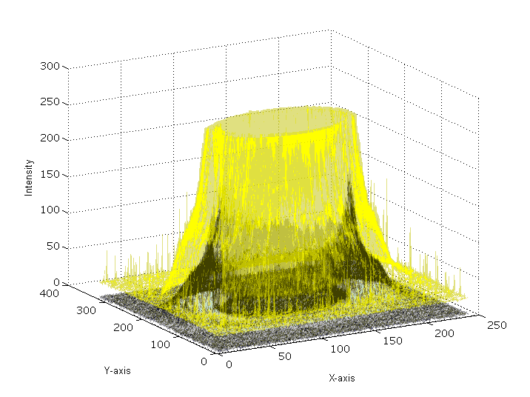
Figure 1. Tolerance Range across Pixels within an Image

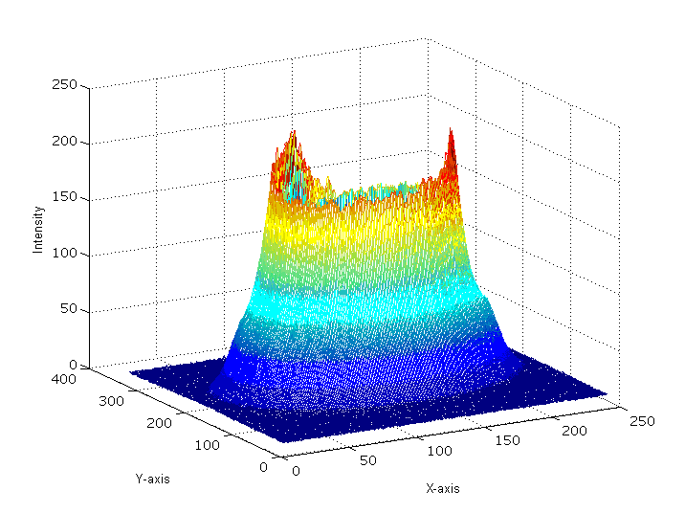
Figure 2. Average across Pixels within an Image

Conclusions

In summary, it has been shown that the initial set of calibration images used in the assessment of environmental factors showed that machine ID was a significant factor (Table 3) in the assessment of a ‘Pass’ image. When taking the new set of calibration images, all images from SN007 failed which agreed with the conclusion from the assessment of the initial set of calibration images. It has been determined that SN007 should be put through the Returned Materials Authorization (RMA) process in order to initiate an investigation of the potential cause for the variability in image quality.

The new set of adhoc images showed no difference between machine type and had the highest predicted probability of having an image be assessed as ‘Pass’. Since no difference exists in machines SN009 and SN025 in the adhoc manner of collecting images, one set of limits was derived and calculated. Verification of these pixel tolerance ranges resulted in an allowance of <10% of the 76,800 pixels within an image to be outside of their respective range. Based on this new process, 99 out of 100 randomly chosen images were qualitatively assessed as ‘Pass’ and were qualified as ‘Pass’ with this new process. Therefore, the new calibration process will be implemented within the ClearView software solution.

As a point of clarification, the calibration pass/fail assessment determines the device’s ability to create a reproducible small high frequency electric charge at the electrode surface as well as whether the device set up (e.g., glass electrode cleanliness, hot/cold camera pixels, and calibration probe positioning) is within defined requirements. Device qualification performed on the manufacturing line (i.e., acceptance testing) will provide an accurate assessment of device performance to established requirements. The device qualification testing is being developed as a part of the transfer of engineering technology from development to manufacturing. The ClearView software solution calibration process is intended to be used by the device user to assess performance on a daily basis. The use of the ClearView software solution calibration process in device qualification testing is yet to be established.

Lastly, now that the image collection and analysis are complete, the following recommendations are requested to be implemented:

- A flag to determine Machine ID for each image.

- The calibration log will always be filled in with exact numerical data and no quotes, lines, arrows, summary text (e.g. “remained relatively consistent”) or any other short hand text will be used.

- To develop a plan to for ClearView device validation and verification.

- To revisit the calibration testing as needed.

References
Conover, WJ. Practical Nonparametric Statistics 2nd Edition, p118. John Wiley & Sons: New York, 1980.

Approval

Department | Signature | Date
Medical
IT
QA

